Adjustment procedure for two-stage-trigger
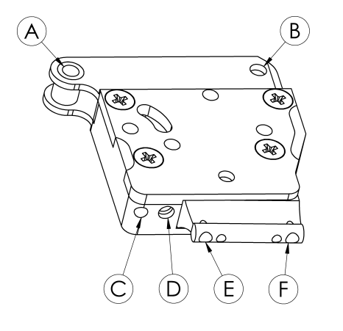
screw C (socket screw M3): with this screw you can adjust the release force of the trigger. The complete
release force is the summary of the first stage force (screw F) and release force
adjusted with the screw C. Below the screw C the standard spring
(0,25mm x 3,7mm) is installed. With this spring installed the
range is adjustable from 5g up to approx. 100g.
If standard spring is replaced by spring 0,4mm x 3,9mm the adjustable range is
adjustable from approx. 100g up to 250g.
(turn screw clockwise - force increases)
(turn screw cont.-clockwise - force degreases)

screw D (socket screw M3): with this screw you can adjust the sear engagement
(turn screw clockwise - less engagement)
(turn screw cont.-clockwise - more engagement)

WARNING: Insufficiently or poorly adjusted sears and/or triggers are extremely dangerous and
may cause serious injuries!

screw E (socket screw M3): the travel range of the trigger shoe up to the first stage can be adjusted
(turn screw clockwise - less travel)
(turn screw cont.-clockwise - more travel)

screw F (socket screw M3): with this screw the force of the first stage is adjustable. Below this screw
the standard spring (0,2mm x 13mm) is installed. With this spring installed the
first stage force is adjustable from approx. 20g up to approx. 70g.
If standard spring is replaced by spring 0,3mm x 10mm the first stage force is
adjustable from approx. 70g to approx. 200g.
If standard spring is replaced by spring 0,3mm x 13mm the first stage force is
adjustable from approx. 200g to approx. 400g.

